Lesson 03 Demo 01

Creating a Storage Account Using the Azure Portal

Objective: To create a storage account to store the objects using the Azure portal

Tools Required: None

Prerequisites: None

Steps to be followed:
- Create a storage account using the Azure portal

Step 1: Create a storage account in the Azure portal

  - In the Azure portal, search for Storage accounts and select the option that appears

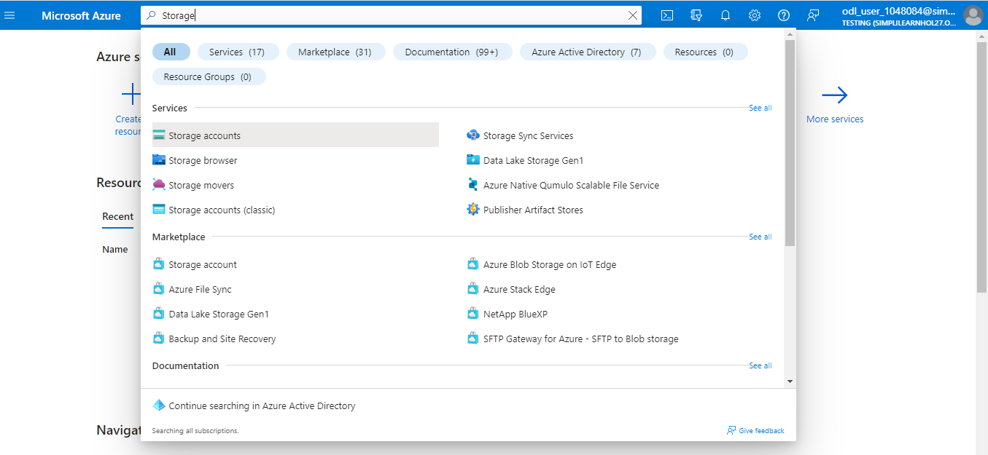

  - Select the subscription in which you want to create the storage account, and then click on Create storage account

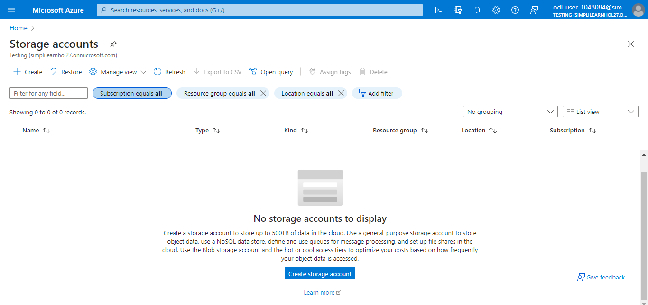

  - Click on Create new

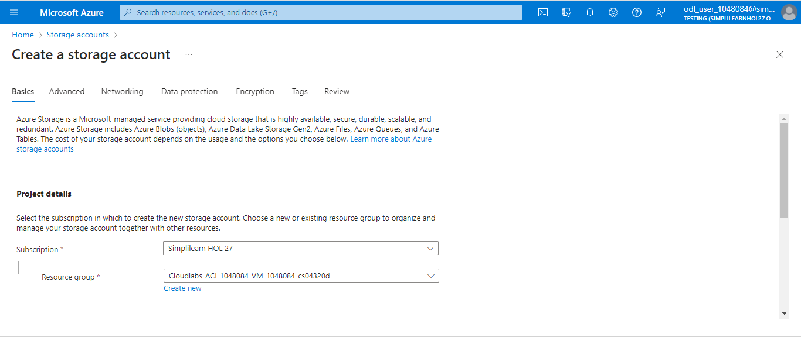

  - Enter a name for the new resource group

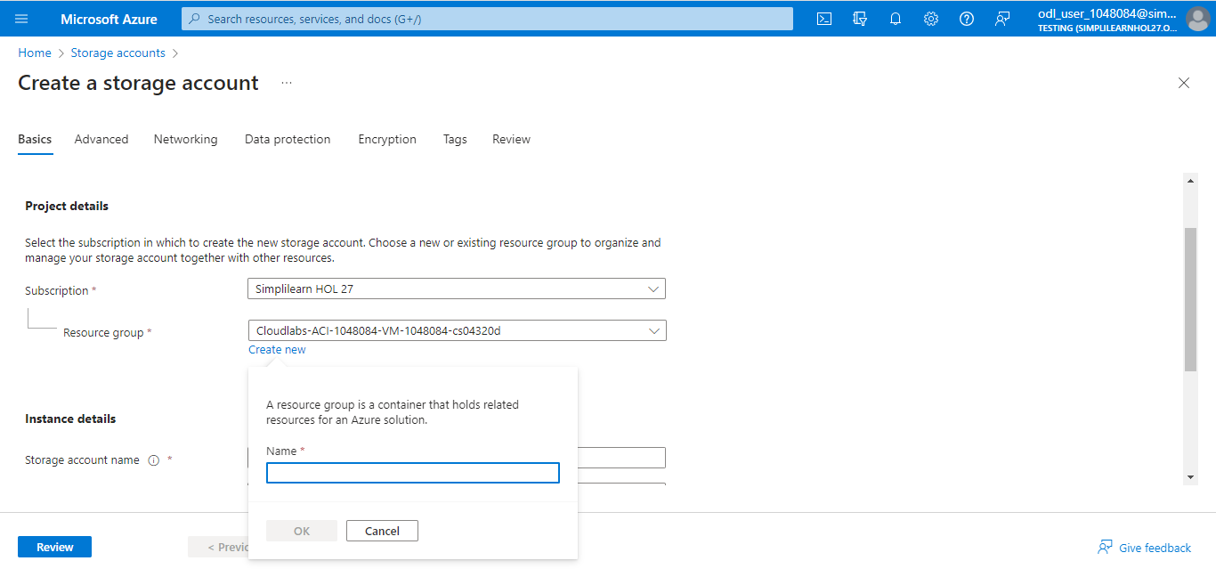

  - Enter a name for your storage account. The name must be unique across Azure; it should be between 3 and 24 characters in length and can include numbers and lowercase letters only.

  - Select a location for your storage account or use the default location

  - Leave these fields set to their default values:
Performance: Standard
Redundancy: Locally redundant storage (LRS)

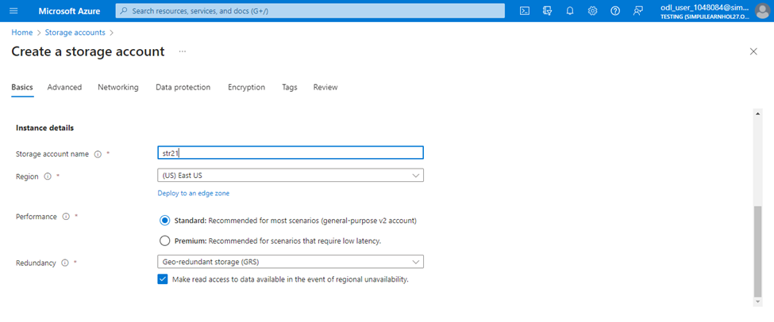

  - Click on Review to review your storage account settings, and then click on Create

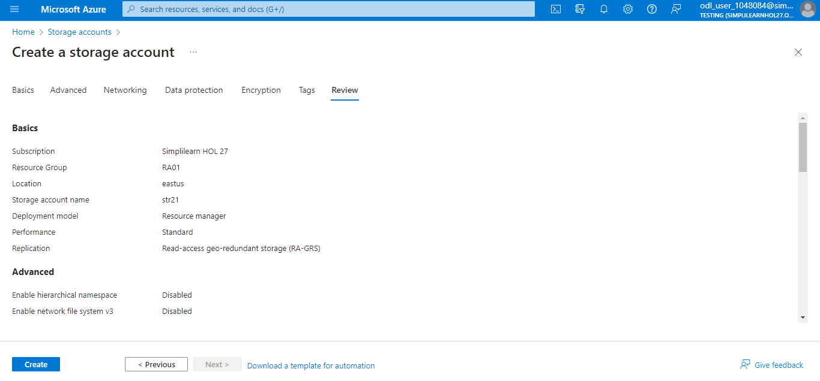

The following screenshot will appear:

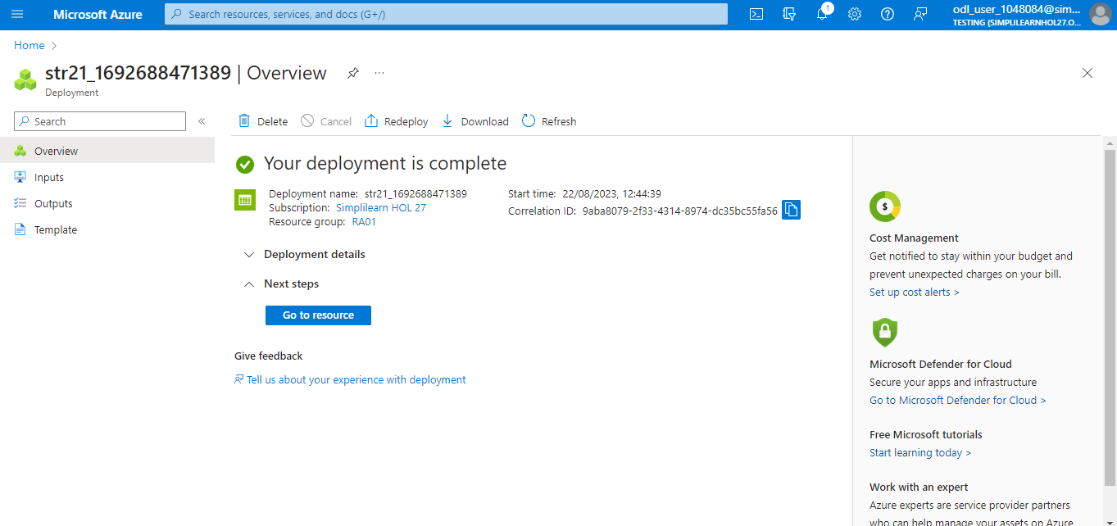

You have now successfully created the storage account using the Azure portal to host your data in Azure.

